**Assignment No# 1**

**(Deep Learning)**

**21L-5617**

**Muhammad Ahmad**

**BS (DS) 7A**

**Question 1: Logistic Regression**

**preprocessing**

First, load the data and visualize it by displaying two images from the dataset. Then, apply preprocessing steps, including normalization, standard scaling, and PCA, and observe the changes after each step.

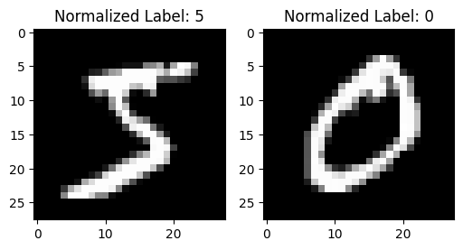 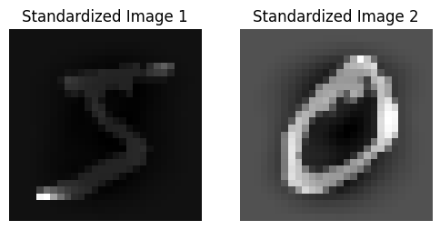

**Part (a)**

In Part A, implement a general Logistic Regression model that works with both TensorFlow and Scikit-learn. Run the model on both the preprocessed images and the original (non-preprocessed) images to compare performance

|  |  |
| --- | --- |

|  |  |  |  |  |  |  |  |  |  |  |  |  |  |  |  |  |  |
| --- | --- | --- | --- | --- | --- | --- | --- | --- | --- | --- | --- | --- | --- | --- | --- | --- | --- |
| |  |  |  | | --- | --- | --- | | **Metric** | **Without Preprocessing** | **With Preprocessing** | | **Accuracy** | 0.9204 | 0.9265 | | **Precision** | 0.9203 | 0.9264 | | **Recall** | 0.9204 | 0.9265 | | **F1 Score** | 0.9202 | 0.9264 | |  |  |
| This table clearly shows the improvement in model performance after preprocessing the data  **Part (b)**  The model was trained with **SGD**, achieving moderate results. **RMSprop** with 10 epochs showed improvement, but using 100 epochs led to a slight performance drop. **Adam** performed similarly to RMSprop with 10 epochs and slightly improved with 100 epochs. Finally, **Nesterov Accelerated Gradient** with 100 epochs gave the best performance.   |  |  |  |  |  |  |  |  |  |  |  | | --- | --- | --- | --- | --- | --- | --- | --- | --- | --- | --- | | **Optimizer** | |  | | --- | | **Epochs** | | |  | | --- | | **Accuracy** | | |  | | --- | | **Precision** | | |  | | --- | | **Recall** | | |  | | --- | | **F1 Score** | | | SGD | **-** | 0.9239 | |  | | --- | | 0.9237 |  |  | | --- | |  | | 0.9239 | 0.9237 | | RMSprop | 10 | 0.9263 | 0.9263 | 0.9263 | 0.9261 | | RMSprop | 100 | 0.9250 | 0.9250 | 0.9250 | 0.9249 | | Adam | 10 | 0.9250 | 0.9249 | 0.9250 | 0.9248 | | Adam | 100 | 0.9256 | 0.9254 | 0.9256 | 0.9254 | | Nesterov Accelerated Gradient | 100 | 0.9256 | 0.9269 | 0.9270 | 0.9268 |   This table provides a clear comparison of the different optimizers and how the model's performance varies across different epochs and optimization methods.  **Part (c)**  I used 133 rounds for hyperparameter tuning in Part C, focusing on optimizing the learning rate, number of epochs, and batch size. After tuning, the best hyperparameters were found to be:   * **Learning Rate**: 0.0001976 * **Number of Epochs**: 100 * **Batch Size**: 16   Using these values, the model achieved significantly improved performance with the following results:   * **Model Accuracy**: 0.9639 * **Model Precision**: 0.9639 * **Model Recall**: 0.9639 * **Model F1 Score**: 0.9639   **Question 2: Batch Normalization**  When using the previously trained batch size without batch normalization, the model achieved the following performance:   | **Metric** | **Without Batch Normalization** | **With Batch Normalization** | | --- | --- | --- |  |  |  |  | | --- | --- | --- | | **Accuracy** | 0.9258 | 0.9201 |  |  |  |  | | --- | --- | --- | | **Precision** | 0.9257 | 0.9199 |  |  |  |  | | --- | --- | --- | | **Recall** | 0.9258 | 0.9201 |  |  |  |  | | --- | --- | --- | | **F1 Score** | 0.9257 | 0.9199 | |  |  |

**Without Batch Normalization**

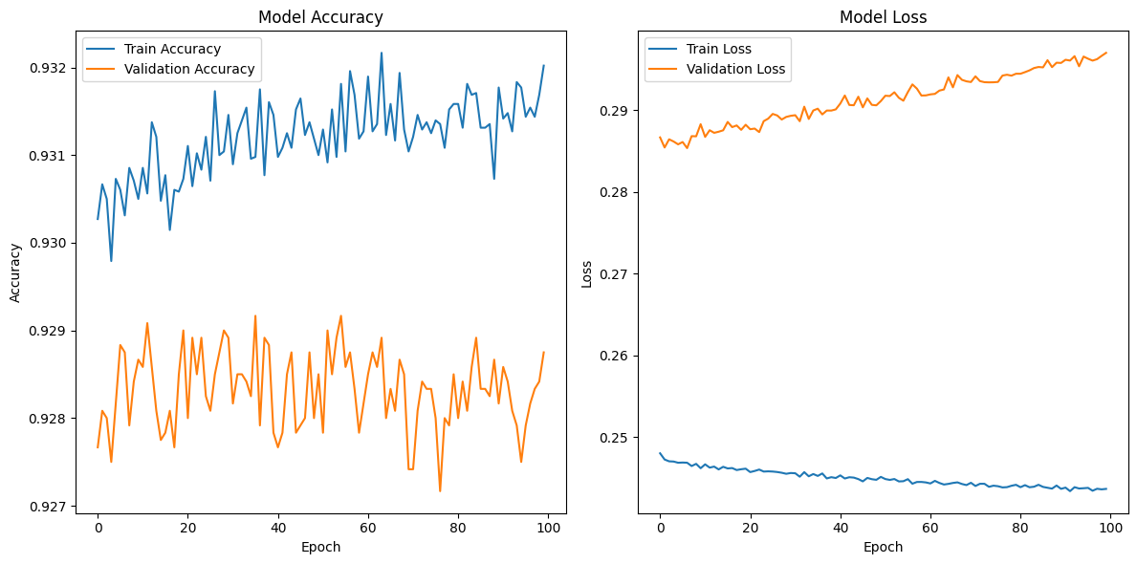

**With Batch Normalization**



In both cases, training accuracy, validation accuracy, and training loss were the same, but batch normalization led to a more significant decrease in validation loss, indicating better generalization.

**Question 3: Gradient Descent and Its Variants**

|  |  |  |  |  |  |  |  |  |  |
| --- | --- | --- | --- | --- | --- | --- | --- | --- | --- |
| |  | | --- | | **Gradient Descent Method** | | |  | | --- | | **Accuracy** | | |  | | --- | | **Precision** | | |  | | --- | | **Recall** | | |  | | --- | | **F1 Score** | |
| |  | | --- | | Simple Gradient Descent | | |  | | --- | | 0.9236 | | |  | | --- | | 0.9237 | | |  | | --- | | 0.9236 | | |  | | --- | | 0.9235 | |
| |  | | --- | | Stochastic Gradient Descent | | |  | | --- | | 0.9235 | | |  | | --- | | 0.9234 | | |  | | --- | | 0.9235 | | 0.9233 |
| |  | | --- | | Mini-batch Gradient Descent | | 0.9226 | |  | | --- | | 0.9227 | | |  | | --- | | 0.9226 | | |  | | --- | | 0.9225 | |

The training loss decreases exponentially for Simple Gradient Descent over 100 epochs, shows a rapid but rough decline for Stochastic Gradient Descent, and reaches a smooth convergence with Mini-batch Gradient Descent, all within approximately 10 epochs.

**Basic Gradient Decent SGD**

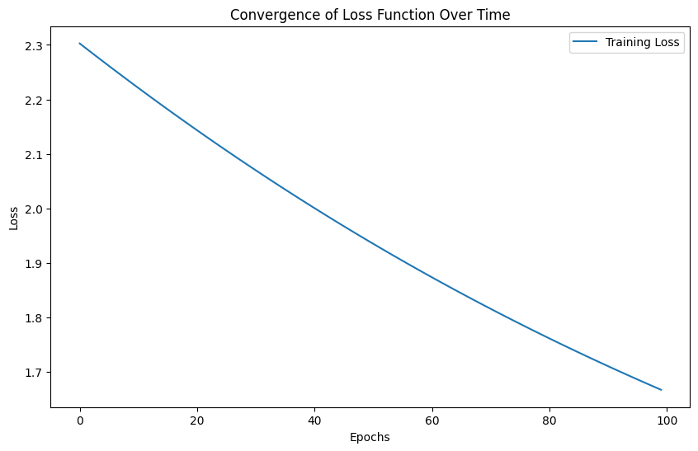 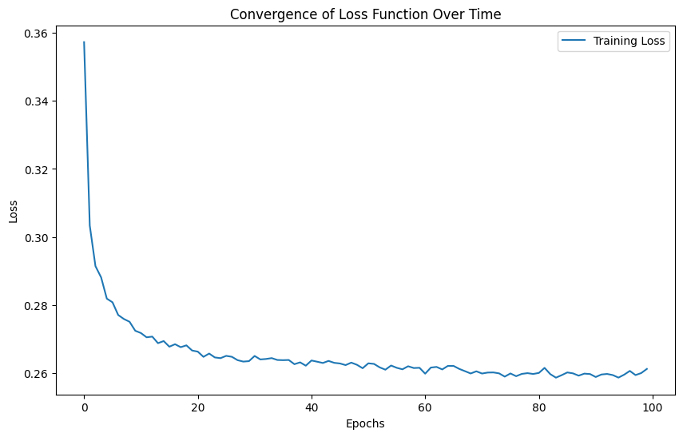

**Mini batch DS**

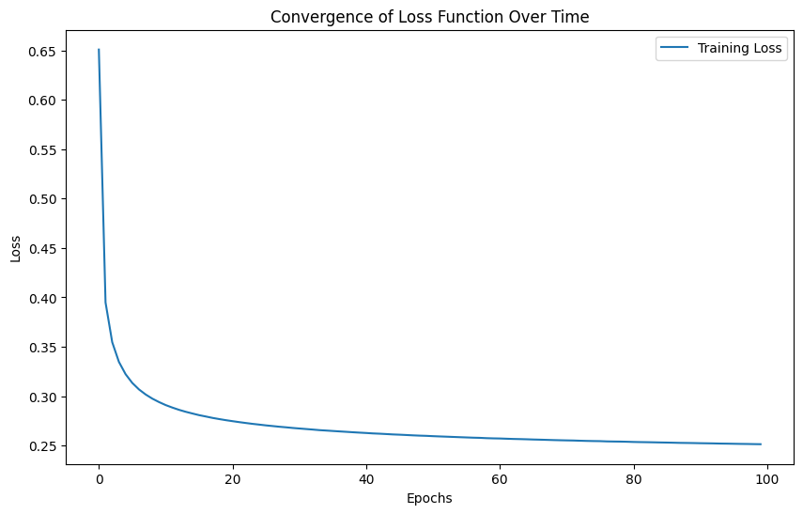

**Question 4: Hyperparameter Tuning**

**Data Preprocessing**

The dataset was preprocessed using:

* **Normalization**: Scaled pixel values to the range [0, 1].
* **Standard Scaler**: Standardized the data to have a mean of 0 and a standard deviation of 1.
* **PCA**: Reduced dimensionality to enhance training efficiency.

#### Tuning Process

Using the **KerasTuner** library, hyperparameter tuning was performed for:

* **Learning Rate**: Tuned to find the optimal value.
* **Number of Layers**: Explored 1 to 5 layers.
* **Batch Size**: Various sizes tested.
* **Dropout Rate**: Adjusted from 0 to 0.5.

#### Results

The best hyperparameters found were:

* **Learning Rate**: 0.00021183086516208134
* **Number of Layers**: 2
* **Units per Layer**: [224, 224]
* **Dropout Rates**: [0.4, 0.1]
* **Batch Size**: 16

#### Model Training

The neural network was trained for 100 epochs, yielding:

* **Model Accuracy**: 0.9808
* **Model Precision**: 0.9808
* **Model Recall**: 0.9808
* **Model F1 Score**: 0.9808

**Comparison**

The tuning process significantly enhanced model performance, achieving the highest accuracy of 0.9808, which outperformed all previous experiments conducted throughout this project, including those using logistic regression and various gradient descent methods. This improvement highlights the importance of optimizing hyperparameters, as it led to more effective learning and classification compared to earlier results with models like SGD and Mini-batch Gradient Descent.